"Loan Default Analysis: Insights from Lending Club”
“Unlocking Patterns in Peer-to-Peer Lending"

Presented By : Mariam Irfan

Introduction:
In this era of financial technology, peer-to-peer lending platforms have become increasingly popular as an alternative to traditional banking. One of the most prominent platforms is Lending Club. Understanding loan default patterns is crucial for investors, borrowers, and the platform itself. This project delves into the analysis of loan defaults in the Lending Club dataset, aiming to offer valuable insights into risk assessment, lending practices, and investment strategies.
2. Overview of Dataset:
Source: The dataset used for this analysis was obtained from Lending Club and comprises loan data spanning from 2007 to 2020Q3.
Key Dataset Information:
- Number of Records: 1,000,000+
- Number of Columns: 144
- Data Source: Lending Club
- Data Preparation: The dataset underwent rigorous data preprocessing to address missing values, duplicates, and outliers, ensuring data quality for analysis.
3. Objectives:
The project's core objectives include:
- Assess Loan Default Risk: Evaluate and quantify the risk of loan defaults within the dataset.
- Identify Default Predictors: Determine which factors significantly influence the likelihood of loan defaults, such as credit scores, employment length, and loan grades.
- Understand Default Trends: Analyze historical trends in loan defaults over different time periods, providing insights for risk management.
- Provide Data-Driven Recommendations: Offer recommendations to Lending Club and investors for better decision-making regarding loan approval and investment strategies.
4. Main Questions:
The primary research questions guiding the analysis are as follows:
- What is the trend in loan approval and default rates over the years?
- How does employment length and other factors affect loan default rates?
- Are there specific factors that contribute to high recoveries from defaulted loans?

5. Stakeholders:
This project has several key stakeholders, each with unique interests in the analysis:
- Lending Club Management: Lending Club is keenly interested in managing and minimizing loan defaults as it directly impacts their profitability and reputation. They would benefit from insights that help refine their lending policies and risk assessment.
- Investors: Investors, including individuals and institutional investors, are stakeholders concerned about maximizing returns while minimizing risks. They rely on insights into default rates to make informed investment decisions.
- Regulatory Bodies: Regulatory bodies overseeing peer-to-peer lending platforms like Lending Club may use the analysis to ensure compliance with financial regulations and consumer protection.
- Borrowers: Understanding loan default patterns can also benefit borrowers by improving transparency in lending practices and potentially influencing interest rates and lending terms.
- Data Analysts and Data Scientists: Professionals working on data analysis projects can utilize the insights generated from this analysis to improve their predictive models and analysis techniques.
6. Methodology:
The analysis follows a structured methodology involving data preprocessing and exploratory data analysis (EDA). The code and tools used include Python, pandas and data visualization libraries.
7. Results and Insights:
This section summarizes the main findings and insights from the analysis, addressing the primary research questions and objectives.
- Default Rate based on Employee Length
The default rate based on employee length provides lenders and investors with crucial insights into borrowers' credit risk and employment stability. A lower default rate among borrowers with longer employment histories suggests that they are more likely to maintain stable income sources, making them attractive candidates for loan repayment. These insights enable lenders to tailor lending strategies, adjust lending policies, and make informed credit decisions. Additionally, the analysis can reflect economic trends and help stakeholders mitigate risk and optimize lending practices.
Code:
df[["emp_length", "loan_status"]].value_counts()
df[["emp_length", "loan_status"]].value_counts()
df[df["loan_status"]=="Default"]["emp_length"].value_counts()
df[df["loan_status"]=="Default"]["emp_length"].value_counts()
Result:
1 year 0.021745
10+ years 0.013837
2 years 0.008519
3 years 0.016722
4 years 0.010719
5 years 0.014732
6 years 0.012049
7 years 0.011697
8 years 0.005596
9 years 0.009755
< 1 year 0.015003

Visualization

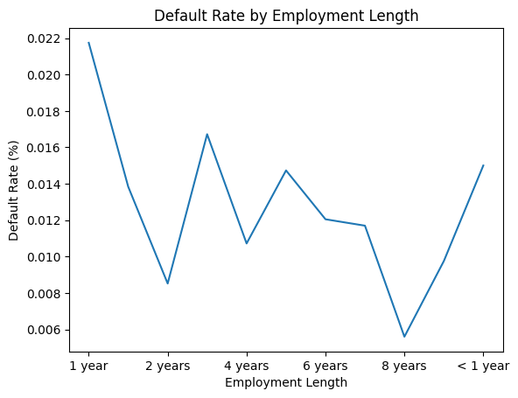

Interpretation:
The loan default rate based on employee length reveals valuable insights for risk assessment in lending. Borrowers with 8+ years of employment experience exhibit the lowest default rate, suggesting that their established careers provide a higher level of financial stability and responsibility. On the other hand, those with 2 years or less of employment tenure have a relatively higher default rate, possibly due to the uncertainty that can accompany newer job positions.
Insights & Recommendation:
For lenders, this insight underscores the importance of considering employment history when evaluating creditworthiness. To mitigate risk, they may choose to offer more favorable terms to borrowers with longer job stability while exercising caution with those in the early stages of their careers. Furthermore, assessing employment length as part of a holistic credit evaluation process can lead to better-informed lending decisions and reduced default risk.

2.Default Rate based on Annual Income

Analyzing the default rate based on annual income is highly valuable in understanding the financial risk associated with borrowers. It provides insights into how borrowers' income levels correlate with their ability to meet loan obligations. A higher default rate among lower-income borrowers suggests increased financial vulnerability, emphasizing the importance of income verification and tailored lending terms for this group. On the other hand, a lower default rate for higher-income borrowers indicates greater financial stability. Lenders can leverage this insight to optimize loan approval processes, offering competitive terms to lower-risk, higher-income borrowers while implementing risk-mitigation strategies for those with lower incomes, ultimately enhancing lending efficiency and reducing default rates.

Code:
import pandas as pd
import matplotlib.pyplot as plt

# Step 1: Select relevant columns and copying it to a new dataframe 'df_annualinc_loan_status'
df_annualinc_loan_status = df[["annual_inc", "loan_status"]].copy()

# Step 2: Define income bins and labels
income_bins = [0, 40000, 60000, 80000, 100000, float('inf')]
income_labels = ['<40k', '40k-60k', '60k-80k', '80k-100k', '100k+']

# Step 3: Create 'annual_inc_bucket' column
df_annualinc_loan_status['annual_inc_bucket'] = pd.cut(
df_annualinc_loan_status["annual_inc"],
bins=income_bins,
labels=income_labels,
right=False
)

# Step 4: Calculate default rates per income bucket
default_rates = df_annualinc_loan_status.groupby('annual_inc_bucket')['loan_status'].apply(
lambda x: (x == 'Charged Off').mean()
)

# Step 5: Plot the bar chart
fig, ax = plt.subplots(figsize=(7, 5))

# Plot the bar chart
bars = ax.bar(default_rates.index.astype(str), default_rates.values, color='steelblue')

# Add labels and title
ax.set_title("Default Rate by Income Groups")
ax.set_xlabel("Annual Income Bucket")
ax.set_ylabel("Default Rate")

# Add percentage labels above bars
for bar in bars:
height = bar.get_height()
ax.text(
bar.get_x() + bar.get_width() / 2,
height + 0.005,
f"{height:.2%}",
ha='center', va='bottom'
)

# Rotate x labels if needed
plt.xticks(rotation=45)

# Improve layout
plt.tight_layout()

# Show plot
plt.show()

Results & Visuals
Loan Default Rates by Annual Income Bucket:
annual_inc_bucket
<40k 0.139268
40k-60k 0.125761
60k-80k 0.116030
80k-100k 0.106268
100k+ 0.089821

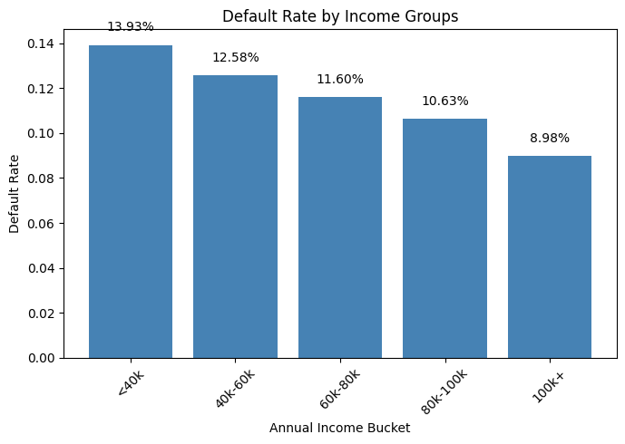
Insight:
The analysis of loan default rates by annual income bucket reveals a clear inverse relationship between income levels and default rates. As borrowers' annual income increases, the likelihood of loan default decreases. The lowest default rate is observed among borrowers with an annual income of 100k or more, indicating greater financial stability within this group.
Recommendation:
Lenders should consider adjusting their lending terms and risk assessment criteria to align with borrowers' annual income levels. Higher-risk borrowers with annual incomes under 40k might benefit from tailored repayment plans or additional financial education resources to improve loan repayment reliability. On the other hand, borrowers with incomes of 100k or more represent a lower-risk segment, warranting competitive lending terms to attract and retain financially stable customers. This tailored approach can enhance the overall loan portfolio performance and minimize default rates.

Default Rate in Various Interest Rate Groups

The analysis of default rates in various interest rate groups is a crucial component of risk assessment and decision-making in lending. It provides lenders with insights into the relationship between interest rates and borrower default behavior, allowing for the optimization of interest rate offerings. By understanding the risk associated with different rates, lenders can strike a balance between attracting borrowers with competitive rates and managing potential losses due to defaults. This analysis also informs decisions about loan approvals and setting interest rates, ultimately contributing to more effective lending strategies and a competitive edge in the market.

Code:
df_annualint_loan_status = df[["int_rate", "loan_status"]].copy()

# Define interest rate buckets
interest_rate_bins = [5, 10, 15, 20, float('inf')]
interest_rate_labels = ['<10%', '10%-15%', '15%-20%', '20%+']

# Create 'int_rate_bucket' column using cut
df_annualint_loan_status['int_rate_bucket'] = pd.cut(df_annualint_loan_status['int_rate'], bins=interest_rate_bins, labels=interest_rate_labels, right=False)

# Calculate loan default rates for each interest rate bucket
default_rates = df_annualint_loan_status.groupby('int_rate_bucket')['loan_status'].apply(lambda x: (x == 'Charged Off').mean())

print("Loan Default Rates by Interest Rate Bucket:")
print(default_rates)

#Plot a visual
(default_rates).plot.pie(title="Default Rate by Interest Rate")

Results and Visual
Loan Default Rates by Interest Rate Bucket:
int_rate_bucket
<10% 0.046648
10%-15% 0.102375
15%-20% 0.168668
20%+ 0.244728

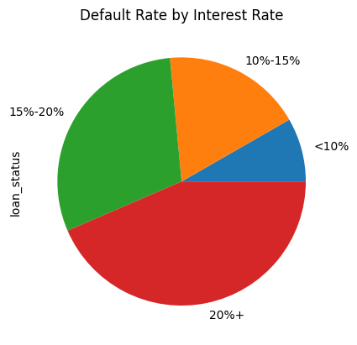

Insights and Recommendation

The data reveals a clear correlation between the interest rate offered and loan default rates. Loans with interest rates below 10% have the lowest default rate, while those with rates above 20% have the highest default rates. Borrowers who accept loans with higher interest rates are more likely to default, possibly due to financial stress or higher credit risk.

Recommendation

This insight emphasizes the importance of offering competitive and personalized interest rates, tailored to borrowers' creditworthiness. Lenders should focus on risk-based pricing, provide financial education for higher-rate borrowers, and explore alternative lending products to mitigate default risks and foster a more stable lending environment.

Analysis of Loan Status vs. Debt-to-Income (DTI) Ratio

The analysis of Loan Status vs. Debt-to-Income (DTI) Ratio is essential because it highlights the relationship between borrowers' debt management and loan repayment. It provides valuable insights into how a borrower's DTI ratio affects their ability to meet loan obligations. High DTI ratios are associated with a higher default rate, indicating that borrowers with significant existing debts relative to their income are more likely to face challenges in repaying new loans. This analysis underscores the importance of responsible lending practices, where lenders should assess a borrower's DTI ratio and consider it when determining loan eligibility and terms. It also suggests that borrowers with high DTI ratios may benefit from financial counseling or debt consolidation options to improve their repayment capacity.

Code:

#Select columns "dti" and "loan_status" from dataframe

df_dti_loan_status = df[["dti", "loan_status"]].copy()

# Define DTI buckets

dti_bins = [0, 15, 20, 25, float('inf')]

dti_labels = ['0-15', '15-20', '20-25', '25+']

# Create 'dti_bucket' column using cut

df_dti_loan_status['dti_bucket'] = pd.cut(df_dti_loan_status['dti'], bins=dti_bins, labels=dti_labels, right=False)

# Calculate loan default rates for each DTI bucket

default_rates = df_dti_loan_status.groupby('dti_bucket')['loan_status'].apply(lambda x: (x == 'Charged Off').mean())

print("Loan Default Rates by DTI Bucket:")

print(default_rates)

#Plot a visual

(default_rates).plot.pie(title="Default Rate by Debt to Income Ratio")

Results and Visuals

Loan Default Rates by DTI Bucket:
dti_bucket
0-15 0.103635
15-20 0.112860
20-25 0.123353
25+ 0.131020

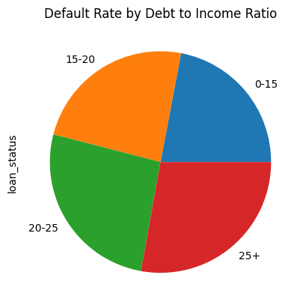

Insights and Recommendations

Insights:

The analysis of Loan Default Rates by DTI Bucket reveals that as the debt-to-income (DTI) ratio increases, the default rates also exhibit an upward trend. Borrowers with higher DTI ratios tend to have a higher likelihood of default.

Recommendation:
To mitigate this, lenders should consider setting stricter eligibility criteria for borrowers with high DTI ratios. Additionally, borrowers with elevated DTI ratios should prioritize debt reduction strategies and financial planning to enhance their capacity for loan repayment. This insight underscores the importance of responsible borrowing and lending practices in managing and reducing loan defaults.

Impact of Loan Grade on Default Rate

The analysis of the impact of loan grade on the default rate is crucial because it provides valuable insights into the effectiveness of Lending Club's risk assessment and loan grading system. Understanding how different loan grades correlate with default rates helps lenders, investors, and borrowers assess the level of risk associated with each grade. It allows for more informed decision-making when selecting loans to invest in or apply for. Additionally, this analysis can highlight areas where the grading system may need adjustments to better align with actual default patterns, ultimately contributing to more accurate risk management and improved loan quality within the platform.

Code:

import pandas as pd

import matplotlib.pyplot as plt

# Step 1: Select relevant columns and copying it to a new dataframe 'df_annualinc_loan_status'

df_annualinc_loan_status = df[["annual_inc", "loan_status"]].copy()

# Step 2: Define income bins and labels

income_bins = [0, 40000, 60000, 80000, 100000, float('inf')]

income_labels = ['<40k', '40k-60k', '60k-80k', '80k-100k', '100k+']

# Step 3: Create 'annual_inc_bucket' column

df_annualinc_loan_status['annual_inc_bucket'] = pd.cut(

df_annualinc_loan_status["annual_inc"],

bins=income_bins,

labels=income_labels,

right=False

)

# Step 4: Calculate default rates per income bucket

default_rates = df_annualinc_loan_status.groupby('annual_inc_bucket')['loan_status'].apply(

lambda x: (x == 'Charged Off').mean()

)

# Step 5: Plot the bar chart

fig, ax = plt.subplots(figsize=(7, 5))

# Plot the bar chart

bars = ax.bar(default_rates.index.astype(str), default_rates.values, color='steelblue')

# Add labels and title

ax.set_title("Default Rate by Income Groups")

ax.set_xlabel("Annual Income Bucket")

ax.set_ylabel("Default Rate")

# Add percentage labels above bars

for bar in bars:

height = bar.get_height()

ax.text(

bar.get_x() + bar.get_width() / 2,

height + 0.005,

f"{height:.2%}",

ha='center', va='bottom'

)

# Rotate x labels if needed

plt.xticks(rotation=45)

# Improve layout

plt.tight_layout()

# Show plot

plt.show()

Results and Visuals:
Loan Default Rates by Grade (%)
grade
A 0.004885
B 0.015359
C 0.019306
D 0.021163
E 0.032082
F 0.023093
G NaN

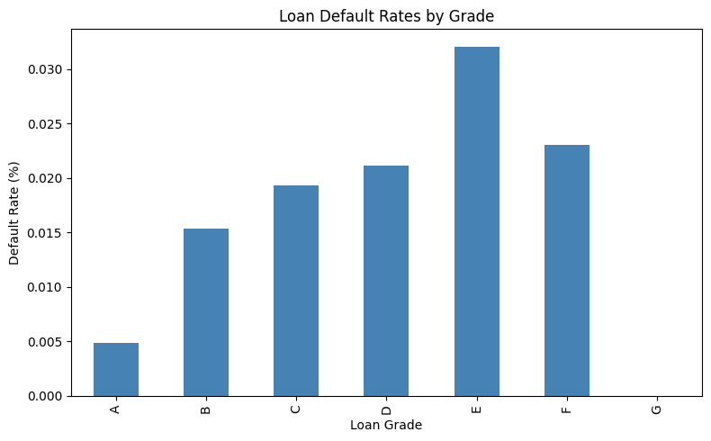

Insights and Recommendations
Insights: The analysis of loan default rates by loan grade shows a progressive increase in default rates from grade A to grade E, with grade G having no data available. This trend indicates that higher-grade loans have a lower likelihood of defaulting, while lower-grade loans carry a higher default risk. Borrowers who prioritize minimizing the risk of default should aim for loans with higher grades, while investors should consider the trade-off between risk and return.
Recommendations: For borrowers, understanding the default risk associated with different loan grades is crucial for making informed borrowing decisions. Investors should use this insight to tailor their investment portfolios according to their risk tolerance. Lending Club should maintain transparency and consistency in its grading system to ensure borrowers and investors have confidence in loan classifications.

Relationship between Loan Status and FICO Score

The relationship between loan status and FICO score is of paramount importance as it offers valuable insights into the risk assessment process of lending. By analyzing how FICO scores correlate with loan statuses, financial institutions can fine-tune their lending criteria. A strong inverse relationship, where lower FICO scores are associated with higher default rates, underscores the importance of creditworthiness in loan approval. This analysis allows lenders to make more informed decisions, minimize default risk, and ensure they are extending credit to borrowers who are more likely to meet their repayment obligations. Additionally, it helps borrowers understand the significance of their credit scores in securing loans with favorable terms, making it a critical aspect of risk management and financial well-being.

Code:

#Createing a new DataFrame, df_fico_loan_status, that contains a copy of the columns "fico_range_low," "fico_range_high," and "loan_status" from the original DataFrame df

df_fico_loan_status = df[["fico_range_low","fico_range_high","loan_status"]].copy()

# Define FICO score buckets
def get_fico_bucket(fico_low, fico_high):
avg_fico = (fico_low + fico_high) // 2

if avg_fico < 600:
return 'Poor'
elif avg_fico < 700:
return 'Fair'
elif avg_fico < 750:
return 'Good'
else:
return 'Excellent'

# Create a new column 'fico_bucket' based on FICO scores
df['fico_bucket'] = df.apply(lambda row: get_fico_bucket(row['fico_range_low'], row['fico_range_high']), axis=1)

# Calculate the default rate by FICO score bucket
default_rate_by_bucket = df[df['loan_status'] == 'Charged Off']['fico_bucket'].value_counts() / df['fico_bucket'].value_counts()

#Plot
import matplotlib.pyplot as plt

# Plot
default_rate_by_bucket.plot.bar(title="Loan Default Rate by FICO Score")
plt.ylabel("Default Rate")
plt.xlabel("FICO Score Bucket") # Optional: add x-axis label for clarity
plt.show()

print("Loan Default Rates by FICO Score ")
print(default_rate_by_bucket)

Results and Visuals
Loan Default Rates by FICO Score
Fair 0.142168
Good 0.095935
Excellent 0.061710

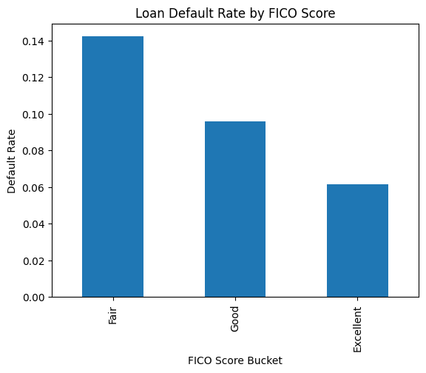

Insights and Recommendations

Insights:

The analysis of loan default rates by FICO score reveals substantial insights. Borrowers with Fair credit scores have a notably higher default rate, emphasizing the need for enhanced risk assessment and potentially offering higher interest rates to mitigate risk. On the other hand, borrowers with Good and Excellent credit scores exhibit significantly lower default rates, signifying their creditworthiness.

Recommendations:

Recommendations include tailored lending criteria for different FICO score categories, offering improved terms to borrowers with strong credit profiles, and implementing enhanced risk assessment measures for those with Fair credit scores to maintain a balanced and profitable lending portfolio.

Relationship of Loan Status with Purpose of Borrowing

The analysis of the relationship between loan status and the purpose of borrowing is valuable for several reasons. It provides insights into the varying default rates associated with different loan purposes, highlighting the risk associated with each category. This analysis allows lenders to tailor their lending policies, interest rates, and risk assessment strategies to specific loan purposes. For borrowers, it offers transparency into the potential default rates associated with their intended use of funds, helping them make informed decisions. Additionally, regulators can utilize this information to monitor and regulate lending practices to ensure consumer protection and financial stability.

Code:
import matplotlib.pyplot as plt

# Step 1: Calculate loan default rate (%) by purpose
Loan_default_by_purpose = (
df[df["loan_status"] == "Default"]["purpose"].value_counts() * 100
/ df["purpose"].value_counts()
)

# Step 2: Plot bar chart
fig, ax = plt.subplots(figsize=(10, 6))

Loan_default_by_purpose.sort_values(ascending=False).plot.bar(
ax=ax,
log=True, # Apply log scale
title="Loan Default Rates by Purpose"
)

# Step 3: Add axis labels
ax.set_xlabel("Loan Purpose")
ax.set_ylabel("Default Rate (%) [Log Scale]")

# Rotate x-axis labels
plt.xticks(rotation=45, ha='right')

# Improve layout
plt.tight_layout()

# Show plot
plt.show()

# Step 4: Print results
print("Loan Default Rates by Purpose (in %):")
print(Loan_default_by_purpose.sort_values(ascending=False))

Results and Visuals
Loan Default Rates by Purpose (in %):
purpose
vacation 0.026994
house 0.020855
debt_consolidation 0.016743
credit_card 0.016563
car 0.016393
small_business 0.015595
home_improvement 0.012942
other 0.011059
major_purchase 0.007888
educational NaN
medical NaN
moving NaN
renewable_energy NaN
wedding NaN
Name: count, dtype: float64

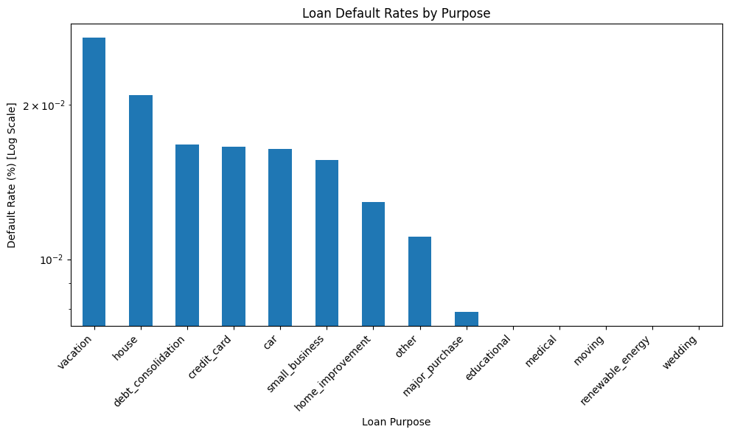

Insights and Recommendations:

The analysis of loan default rates by purpose reveals that certain categories, such as "major_purchase" and "home_improvement," have notably lower default rates, indicating they may be less risky for lenders. Conversely, "vacation" and "house" categories exhibit higher default rates, suggesting higher risk associated with these loan purposes. These insights can guide lenders in adjusting interest rates, underwriting standards, and risk assessment for different purposes. Furthermore, it underscores the need for caution when considering loans for purposes like "vacation" and "house," encouraging borrowers to carefully evaluate their financial capabilities and explore alternative financing options. Additionally, it highlights the importance of further investigation into categories with missing data, such as "educational" and "medical," to better understand their default patterns and develop tailored lending strategies.

Recommendations:
Based on the analysis of loan default rates by purpose, it is recommended that lenders should consider adjusting their lending strategies and risk assessment processes to account for variations in default rates among different loan purposes. For lower-risk categories like "major_purchase" and "home_improvement," lenders may offer more favorable terms, attracting responsible borrowers. However, for higher-risk purposes such as "vacation" and "house," lenders should exercise greater caution, potentially applying stricter lending criteria or charging higher interest rates to mitigate risk. It's essential to focus on addressing the missing data in categories like "educational" and "medical" to understand the specific factors affecting default rates within these groups. By tailoring their approach to different loan purposes, lenders can make more informed lending decisions and minimize default risks. Borrowers are also advised to carefully assess their financial situations and explore alternative financing options before committing to loans for high-risk purposes.
CONCLUSION:
In conclusion, this data analytics project focused on the analysis of loan default rates in a lending dataset, aiming to provide valuable insights and recommendations for both lenders and borrowers. By examining factors such as employee length, annual income, interest rates, debt-to-income ratios, loan grades, FICO scores, and loan purposes, we uncovered essential patterns and variations in loan default rates that can inform lending practices and financial decisions.
Key findings include the influence of employee length on default rates, the inverse relationship between annual income and default rates, the impact of higher interest rates on loan default risk, and the importance of considering purpose-specific risk profiles when extending loans. We also discovered variations in default rates across different FICO score categories and identified specific areas where missing data should be addressed for a more comprehensive analysis.
These insights provide a roadmap for stakeholders. Lenders are encouraged to refine their lending strategies, adjust terms based on risk profiles, and invest in data quality. Borrowers, on the other hand, are advised to make informed financial decisions by understanding how these factors affect their loan repayment abilities.
In conclusion, this project underlines the significance of data-driven decision-making in the lending industry, allowing stakeholders to manage risks effectively, optimize lending practices, and promote financial well-being. By leveraging these insights, both lenders and borrowers can contribute to a healthier and more sustainable lending ecosystem.

9. Conclusion:
A concluding section highlights the key takeaways from the analysis and reinforces the project's objectives and their fulfillment.

